II B. Tech. I Semester Supplementary Examinations – July, 2024
programming in c
(ece)
Time: 150 Min Max. Marks: 80M

SECTION – A
Answer all Four questions 4×10M=40M

- A binary file contains only 0’s and 1’s. Observe the patterns in the string and design algorithms for the following problems.
a) Print the maximum number of continuous 1’s in the binary string.
b) Print sum of all numbers in the string
c) Print no.of even numbers
d) Print no.of odd numbers
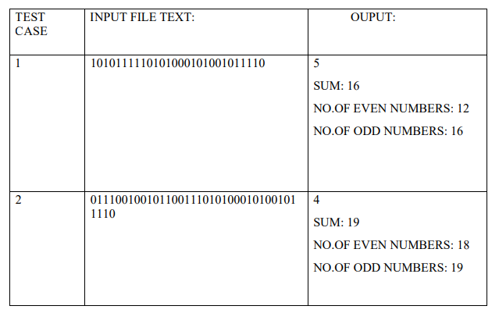

- Design an algorithm to develop an Employee Management System having ‘n’ number of
employees. The details of employees are given below.

Salary Band Range of Salary/Annum
A < 5L
B 5L to 10L
C 10L to 20L
D 20L to 30L
E >30L

a. Create employee record (Using structures) – the user can create an employee record with the following details. [NOTE : Employee ID should be unique]
i. Name
ii. Gender
iii. Age
iv. Salary
v. Employee ID
b. Search for Employee using employee ID
c. Display the ratio of male and female employees.
d. Display the list of male employees and other details in a particular salary band.
e. Display the list of female employees and other details in a particular salary
band.
- The brother-sister duo went to shopping and bought “N” items. The items are numbered from 1 to N, and the item “i” weighs “Wi” grams. Little sister insists on helping his brother in carrying the items. She wants her brother to give her a few items. But Big Brother does not want to burden his sister. But she won't stop bothering him unless she is given a few items to carry. So Brother decides to give her some items. Obviously, Brother wants to give his sister less weight to carry. However, his sister is a smart kid. To avoid being given the bare minimum weight to carry, she suggests that the items are split into two groups, and one group contains exactly “X” items. Then Brother will carry the heavier group, and his sister will carry the other group.
- Design a solution to help the Brother in deciding which items his sister should take.
- Find the maximum possible difference between the weight carried by him and the weight carried by his sister.
- Ramesh owns a shawarma food truck in Manila. There are only three types of coins in
Manila: ₹5, ₹10 and ₹15. The Shawarma costs ₹5. There are “N” people (numbered 11 through N) standing in a queue to buy Shawarma from the food truck. Each person wants to buy exactly one Shawarma. For each valid i, the i-th person has one coin with value ai. It is only possible for someone to buy a Shawarma when Ramesh can give them back their change exactly ― for example, if someone pays with a ₹10 coin, Ramesh needs to have a ₹5 coin that he gives to that person as change.
Initially, Ramesh has no money.

- Design an algorithm that decides whether Ramesh can sell Shawarma to everyone in the queue, in the given order.
- Since he is busy in preparing Shawarma, develop a solution to decide that if he can be served all these people?
SECTION-B
Answer all Two questions 2×20M=40M

- Ram is a student of I year CSE. One day he started reading a book, at one time he felt bore and want to refresh by himself by counting number of paragraphs in a page, number of lines in each paragraph, number of words in each line and number of letters in each word. As Raju is weak in programming, he started doing all these manually. Analyse the above requirements by taking string as input and design a solution for the following requirements.
- Print number of vowels, consonants & special characters,
- Print number of upper case letters & lower case letters
- Print number of digits & space

- Create 3 files FileA, FileS, and FileD. Copy all Alphabets into FileA, all special symbols into FileS and all digits and spaces to FileD.
- Display the content of FileA, FileS and FileD.

- Consider a scenario of strings with pointers and design an algorithm and pseudo code for the following problems.
- Specify the logic for reading name and surname of 15 students separately.
- Develop a pseudo code for merging of name and surname of all students, and find length of each student using pointer.
- Develop the pseudo code for finding the name and surname of the student separately using function.
- Develop the pseudo code to print all names in reverse order using pointers using function.
- Construct a function to arrange all the names in alphabetical order.

